DiNaDeNa Customer App — Product Requirements Document
Oct 17, 2026 · @alok

1. Overview
DiNaDeNa ("Chowk to Home") is a customer app that lets households and small businesses hire skilled daily wage workers (mason, painter, plumber and similar) in minutes, with verified attendance and UPI payment. It ships as a Next.js web app, an admin panel, and an Android app on the Play Store, all on one Supabase backend.
Problem. Daily wage workers are hired at a physical chowk with no price clarity, no proof of attendance, and no payment record. Customers cannot compare workers or rebook a good one.
Goals
- A customer can find, book and pay a worker without leaving the app.
- Attendance is proven by OTP check-in and check-out, so payment matches hours actually worked.
- Admins can onboard workers, watch live jobs and resolve disputes from one dashboard.
Success metrics (first 90 days after launch)
Metric | Target
Booking confirmed within 10 minutes of posting a job | 70% of bookings
Bookings with OTP check-in and check-out completed | 90%
Payments completed in-app (UPI) | 80% of completed jobs
Customers who rebook within 30 days | 30%
These targets are proposals to agree with the client; they do not change the build scope.
Stack decision. Next.js (App Router, TypeScript) for web and admin; Supabase for auth, Postgres, realtime, storage and server functions; Android delivered by wrapping the Next.js app with Capacitor. This replaces the Node.js/Laravel and MySQL options named in the quotation.

Demo build (current phase)
The goal right now is a working demo the client can click through, not the production release. It runs as the Next.js web app and admin panel on a free Supabase project, with seeded data so every screen has something to show. Sections 4 to 9 describe the full product; the table says what the demo does differently.
Area | In the demo | Left for the full build
Platform | Web app in a mobile-width layout, plus a basic admin panel | Android build and Play Store submission
Login | Mobile OTP using Supabase test phone numbers with a fixed OTP, so no SMS cost | Live SMS provider (Fast2SMS or Twilio)
Data | Seeded: 3 customers, 12 workers across 6 trades, sample bookings, 1 admin | Real worker onboarding
Search and booking | Real queries on the seeded data: category, distance, filters | Same, on real data
Live map | Worker pin moves along a simulated route once the booking is on the way | Real GPS from the worker's phone
Attendance | Real OTP check-in and check-out | Same
Payment | Dummy UPI screen that returns success or failure on tap | Razorpay UPI and webhook
Admin | Approve workers, set daily rate per category, view bookings | Reports export, dispute and refund tools
The seed numbers are proposals and can change without affecting scope.
Demo is done when one person can log in as a customer, search, book, have a worker accept, complete OTP check-in and check-out, pay with the dummy screen and leave a review, and an admin can approve a new worker and change a category rate, all in one sitting.

2. Users and roles
Three roles share one login system. Each user has exactly one role, stored in profiles.role and enforced by Supabase row level security.
Role | Who | Can do
Customer | Household or small business hiring workers | Search workers, post jobs, book, track live, give attendance OTP, pay by UPI, review
Worker | Skilled daily wage worker | Create profile and skills, accept or reject bookings, share live location on a job, check in and out with OTP, see earnings
Admin | DiNaDeNa staff | Verify workers, manage categories and pricing, monitor jobs and payments, handle disputes, view reports
The quotation lists "Worker & Customer panels": the worker side is a screen set inside the same Next.js app (and the same Android build), not a separate app.

3. Scope
The build fixed at INR 50,000 covers the items below; everything under add-ons or out of scope is quoted or billed separately.
In scope (development, INR 50,000)
- All 12 screens as customer and worker flows, on web and Android
- Admin panel and dashboard
- Supabase project setup: database, auth, storage, realtime, server functions
- Mobile OTP login and OTP attendance
- UPI payment: a dummy payment flow first, live Razorpay once the client's business KYC is done
- Live map with worker location
- Ratings and reviews
- Play Store build and submission
- 1 year free maintenance after delivery
- Full source code handover after final payment
Add-ons (paid by client to third parties)
- Google Play Developer fee: INR 2,950 (INR 2,500 + 18% GST)
- Domain: INR 550/year (.in) or INR 1,200/year (.com)
- Supabase plan, Vercel or other hosting, Google Maps and SMS billing beyond free tiers, Razorpay transaction fees
Out of scope
- iOS app (separate add-on: INR 15,000 plus Apple fee of USD 99/year)
- Worker onboarding and content creation
- Maintenance contract after the 1-year free period

4. Functional requirements
One row per screen in the approved mockup. Every screen is available in English and Hindi; the language choice is saved on the profile.
# | Screen | Requirement | Done when
01 | Welcome and language | Pick English or Hindi on first launch; skip on later launches | Choice persists after app restart
02 | Login and OTP | Mobile number login with 6-digit SMS OTP; OTP expires in 5 minutes; 3 wrong tries lock for 15 minutes | New user lands on profile setup, returning user on home
03 | Home: search and post job | Search by category and area; shortcut to post a job; recent bookings strip | Category search returns workers within 10 km sorted by distance
04 | Post job form | Category, date, start time, duration, address pin, notes, optional photo | Job saved as open and visible to matching workers
05 | Worker search results | List with photo, skill, rating, daily rate, distance, availability; filter by rating and price | Filters change results without page reload
06 | Worker profile and booking | Skills, rating, reviews, rate, past jobs count; "Book" button | Booking request created with status requested
07 | Booking review and confirmation | Summary of worker, time, address, estimated amount; confirm | Customer sees confirmation and worker is notified
08 | Booking status and worker response | Live status: requested, accepted, rejected, on the way, in progress, completed; worker has 10 minutes to respond | Status updates on screen within 3 seconds of change
09 | Active job with live map | Customer sees worker position on a map while status is on the way or in progress | Position refreshes at least every 10 seconds
10 | Attendance | Customer shows a 4-digit OTP; worker enters it to check in, and again to check out | Check-in and check-out times saved; mismatched OTP rejected
11 | Payment | Dummy UPI payment for now: the customer taps pay and a mock gateway returns success or failure; receipt shown. Real UPI replaces the mock later | Payment marked paid only by the payment function (mock now, verified Razorpay webhook later)
12 | My bookings | History with filters, status, receipt, rebook and review actions | Past bookings load 20 at a time
Admin panel (web only)
- Dashboard: bookings today, active jobs, revenue, new workers
- Worker verification: view ID and photo, approve or reject, suspend
- Categories and pricing: add or edit trades and default daily rates
- Bookings and payments: search, view timeline, mark dispute, trigger refund
- Reports: CSV export of bookings and payments by date range

5. Architecture
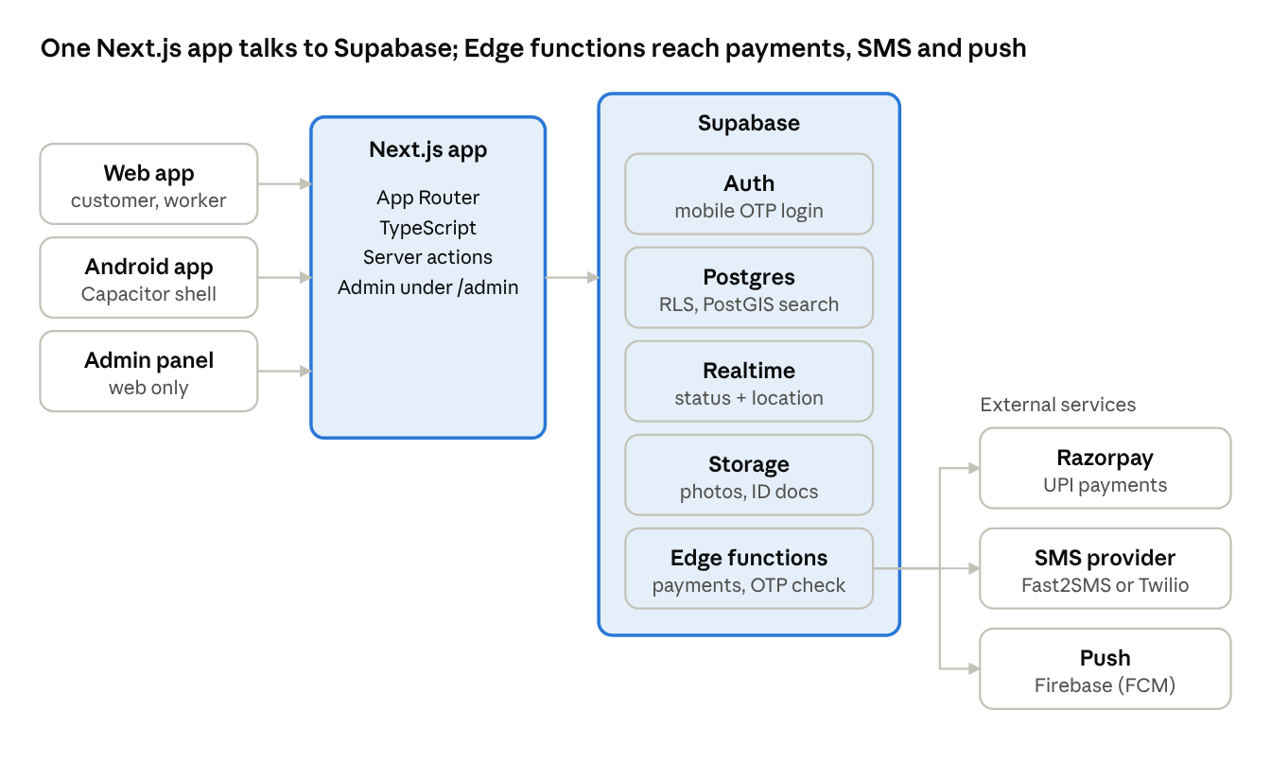
architecture · 3 clients, 1 Next.js app, Supabase, 3 external services
The Next.js app serves the web, the admin panel and the Android shell; every data call goes to Supabase, and anything that touches money or OTP secrets runs in an Edge function.
- Android: Capacitor wraps the production Next.js build, with native plugins for location and push; a signed app bundle goes to the Play Console.
- Maps: Google Maps JavaScript API loads in the client for the search map and live tracking.
- Login OTP: Supabase phone auth with a send-SMS hook that calls Fast2SMS or Twilio.
- Payments: for now a dummy payment function marks the booking paid; when live payments start, one function creates the Razorpay order and a second verifies the webhook signature.
- Hosting: Next.js on Vercel or a VPS (client's choice); secrets live in the host and in Supabase, never in the repository.

6. Data model
Postgres on Supabase with PostGIS enabled for distance search. Every table has id (uuid), created_at and updated_at.
Table | Key columns | Notes
profiles | user id (matches auth user), role, full name, phone, language, avatar | One row per auth user
worker_profiles | user id, category ids, bio, verified, available, home location | verified set only by admin
categories | name (English, Hindi), icon, default daily rate | Daily rate is set by admin only
jobs | customer id, category id, address, location, start time, duration, notes, status | open, booked, cancelled
bookings | job id, customer id, worker id, status, amount, attendance OTP hash | Status lifecycle in section 7
attendance_logs | booking id, type (in or out), time, location | Written by a server function after OTP check
worker_locations | booking id, worker id, point, recorded at | Only rows for active bookings; purged after 30 days
payments | booking id, gateway order id, gateway payment id, amount, status | Updated only by the webhook function
wallet_ledger | user id, amount, reason, booking id | Append-only; balance is the sum
reviews | booking id, from user, to user, rating 1 to 5, comment | One review per side per booking
notifications | user id, title, body, read, device token | Push and in-app
Row level security
- Customers read and write only their own jobs, bookings and payments.
- Workers read bookings assigned to them and write only their own profile and location rows.
- Anyone signed in can read verified worker profiles and reviews; phone numbers stay hidden until a booking is accepted.
- payments, attendance_logs and wallet_ledger are written only by server functions using the service role, never from the client.
- Admin access is a role claim checked in every policy, not a separate database user.

7. Core flows
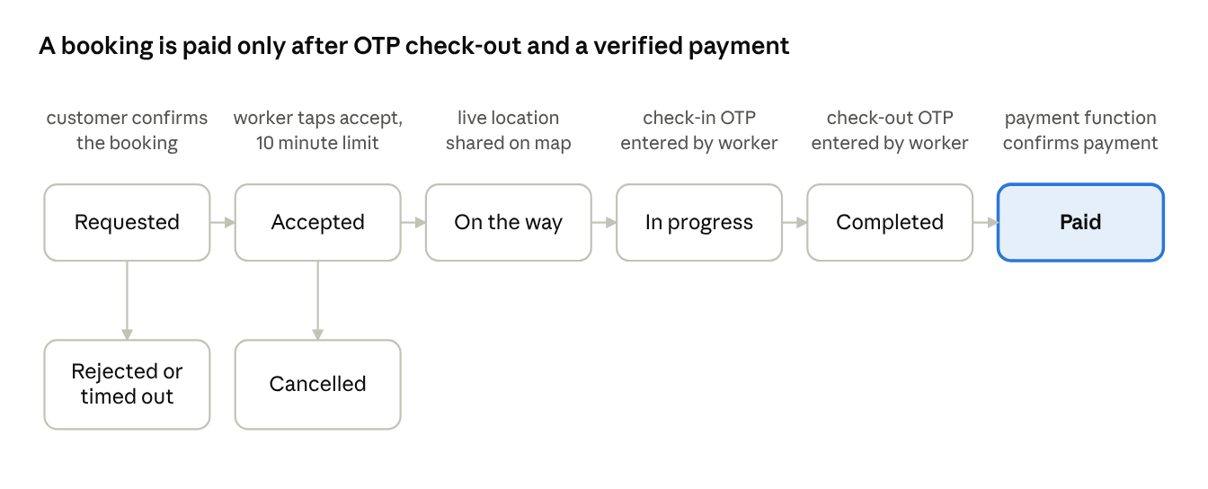
booking lifecycle · 6 statuses, 2 exits
Statuses only move forward. The worker's OTP entry and the payment function are the two events a client cannot fake.
- Attendance OTP: on arrival the customer app shows a 4-digit OTP (stored hashed). The worker enters it, and a server function logs time and location and sets in_progress. The same step at the end sets completed.
- Payment: the server computes the amount from the admin-set daily rate and the confirmed attendance. For now a dummy payment function marks the booking paid; Razorpay UPI replaces it later with the same status change.
- Live tracking: while a booking is on the way or in progress the worker app writes a location point every 10 seconds; the customer map subscribes through Realtime to that booking's rows only.
- Reject, expire, cancel: a worker reject or a 10-minute timeout ends a request; cancellation after acceptance follows a rule the client still has to set.

8. Non-functional requirements
Area | Requirement
Performance | Home and search load in under 3 seconds on a 4G phone; list screens paginate 20 rows at a time
Realtime | Booking status changes reach the other party in under 3 seconds; worker location every 10 seconds
Security | Row level security on every table; service role key only inside server functions; no secrets in the client bundle
Privacy | Worker and customer phone numbers hidden until booking is accepted; location stored only during an active booking
Payments | Amounts computed on the server; a booking is paid only by the payment function: a mock for now, the verified gateway webhook once Razorpay is live
Language | English and Hindi strings from one translation file; Hindi fonts load without layout breaks
Devices | Android 8.0 and above; web on current Chrome, Edge, Safari and Firefox; layouts work from 360 px width
Availability | Target 99.5% monthly, which is what the chosen Supabase and hosting plans support; daily database backups on a paid Supabase plan
Accessibility | Touch targets of at least 44 px, readable contrast, labels on all form fields
Maintainability | TypeScript throughout, database changes as migration files in Git, README for setup and deploy

9. Milestones and delivery
Build order: the web app first (phases 1 to 5), then the Android build. The quotation leaves the timeline open until scope is finalised, so phases below have no dates yet. Work starts after the 20% advance (INR 10,000), the logo, and the client email ID are received; the remaining 80% (INR 40,000) is due on delivery and deployment.
- Setup: Next.js project, Supabase project, auth with mobile OTP, database schema and row level security, Hindi and English strings.
- Customer flow: screens 01 to 08 and 12 on web: search, post job, book, status.
- Worker flow and attendance: worker profile, accept or reject, live location, OTP check-in and check-out (screens 09 and 10).
- Payments and reviews: dummy UPI payment, receipts, ratings. Live Razorpay and the webhook function come later.
- Admin panel: dashboard, worker verification, categories, bookings, reports.
- Android build: Capacitor wrapper, push notifications, location permissions, Play Store listing and submission.
- Testing and handover: end-to-end test of one full booking, deployment, source code and access handover after final payment.
Support: 1 year of free maintenance covers bug fixes in delivered scope from the delivery date. New screens or features need a revised quote.

10. Risks, dependencies and open questions
Risk or dependency | Impact | Mitigation
Supabase phone auth does not send SMS through Indian providers by default | Login OTP fails | Use the send-SMS hook with Fast2SMS or Twilio; client holds the SMS account and DLT registration
Capacitor wrapper feels less native than a Kotlin app | Weaker background location and animation | Keep screens simple; use native location and push plugins; confirm with client that a wrapped app is acceptable
Background location for live tracking is restricted on Android | Map freezes when worker locks phone | Foreground service notification during an active job only
Play Console account needs identity verification | Store submission waits on client | Client opens the developer account at project start
Razorpay needs business KYC and activation | Live payments blocked | Build and test in test mode; client completes KYC in parallel
Google Maps and SMS costs grow with use | Surprise bills | Set billing alerts and quotas; costs stay with client
Supabase free tier pauses idle projects and has no backups | Downtime and data loss risk | Move to a paid Supabase plan before launch
Decisions and open questions
- Decided: the web app is built first, and UPI is a dummy payment for now.
- Decided: the admin sets the daily rate per category.
- Decided: a worker appears in search only after admin approval.
- Assumed, please confirm: a Capacitor-wrapped Android app is acceptable, and the quotation's tech stack changes to Next.js and Supabase.
- Open: is the wallet in screen 11 a real balance with top-up, or UPI at payment time only?
- Open: what happens on cancellation after the worker has accepted: fee, refund, penalty?
- Open: which cities or areas launch first?

